Name:- Sahdab Sayyed
Batch:-A4 Roll No:-231
Assignment 1
SET A
Q1.
Program:
import pandas as pd
df=pd.DataFrame(columns=['Name','Age','Percentage']);
df.loc[0]=('Shadab',20,69)
df.loc[1]=('Aman',22,98)
df.loc[2]=('Awez',20,89)
df.loc[3]=('Ghar',20,75)
df.loc[4]=('Abuzar',20,70)
print(df)

Output:
Name Age Percentage
0 Shadab 20 69
1 Aman 22 98
2 Awez 20 89
3 Ghar 20 75
4 Abuzar 20 70
Q2:-
Program:
import pandas as pd
df=pd.DataFrame(columns=['Name','Age','Percentage']);
df.loc[0]=('Shadab',20,69)
df.loc[1]=('Aman',22,98)
df.loc[2]=('Awez',20,89)
df.loc[3]=('Ghar',20,75)
df.loc[4]=('Abuzar',20,70)
print(df)
print("The Shape:",df.shape)
print("No.of ROws,Columns:",df.size)
print("Data Types:",df.dtypes)
print("Feature name:",df.columns)
print("Description:",df.describe())

Output:
Name Age Percentage
0 Shadab 20 69
1 Aman 22 98
2 Awez 20 89
3 Ghar 20 75
4 Abuzar 20 70
The Shape: (5, 3)
No.of ROws,Columns: 15
Data Types: Name object
Age int64
Percentage int64
dtype: object
Feature name: Index(['Name', 'Age', 'Percentage'], dtype='object')
Description: Age Percentage
count 5.000000 5.000000
mean 20.400000 80.200000
std 0.894427 12.755391
min 20.000000 69.000000
25% 20.000000 70.000000
50% 20.000000 75.000000
75% 20.000000 89.000000
max 22.000000 98.000000

Q3
Program:
import pandas as pd
df=pd.DataFrame(columns=['Name','Age','Percentage']);
df.loc[0]=('Shadab',20,69)
df.loc[1]=('Aman',22,98)
df.loc[2]=('Awez',20,89)
df.loc[3]=('Ghar',20,75)
df.loc[4]=('Abuzar',20,70)
print(df)
print("statical data:",df.describe())
Output:
Name Age Percentage
0 Shadab 20 69
1 Aman 22 98
2 Awez 20 89
3 Ghar 20 75
4 Abuzar 20 70
statical data: Age Percentage
count 5.000000 5.000000
mean 20.400000 80.200000
std 0.894427 12.755391
min 20.000000 69.000000
25% 20.000000 70.000000
50% 20.000000 75.000000
75% 20.000000 89.000000
max 22.000000 98.000000

Q4:
Program:
import pandas as pd
df=pd.DataFrame(columns=['Name','Age','Percentage']);
df.loc[0]=('Shadab',20,69)
df.loc[1]=('Aman',22,98)
df.loc[2]=('Awez',20,89)
df.loc[3]=('Gohar',20,75)
df.loc[4]=('Abuzar',20,70)
df['remark']=None
print(df)
Output:
Name Age Percentage remark
0 Shadab 20 69 None
1 Aman 22 98 None
2 Awez 20 89 None
3 Gohar 20 75 None
4 Abuzar 20 70 None
Q5
Programe:
import pandas as pd
df=pd.DataFrame(columns=['Name','Age','Percentage']);
df.loc[0]=('Shadab',20,69)
df.loc[1]=('Aman',22,98)
df.loc[2]=('Awez',20,89)
df.loc[3]=('Ghar',20,75)
df.loc[4]=('Abuzar',20,70)
print(df)
print("no of observation:",df["Name"].size)
m=df.isnull()
print("missing value:",m)
d=df.duplicated()
print(d)

Output:
Name Age Percentage
0 Shadab 20 69
1 Aman 22 98
2 Awez 20 89
3 Ghar 20 75
4 Abuzar 20 70
no of observation: 5
missing value: Name Age Percentage
0 False False False
1 False False False
2 False False False
3 False False False
4 False False False
0 False
1 False
2 False
3 False
4 False

Q6
Program:
import pandas as pd
df=pd.DataFrame(columns=['Name','Age','Percentage']);
df.loc[0]=('Shadab',20,69)
df.loc[1]=('Aman',22,98)
df.loc[2]=('Awez',20,89)
df.loc[3]=('Ghar',20,75)
df.loc[4]=('Abuzar',20,70)
df['remark']=None
print(df)
df.drop(labels=['remark'],axis=1,inplace=True)
print(df)
df.dropna(axis=0,inplace=True)
print(df)
Output:
Name Age Percentage remark
0 Shadab 20 69 None
1 Aman 22 98 None
2 Awez 20 89 None
3 Ghar 20 75 None
4 Abuzar 20 70 None
Name Age Percentage
0 Shadab 20 69
1 Aman 22 98
2 Awez 20 89
3 Ghar 20 75
4 Abuzar 20 70
Name Age Percentage
0 Shadab 20 69
1 Aman 22 98
2 Awez 20 89
3 Ghar 20 75
4 Abuzar 20 70

Q7:
Program:

#importing Library
import pandas as pd
import matplotlib.pyplot as plt
#Creating Da Frame
df=pd.DataFrame(columns=['Name','Age','Percentage']);
df.loc[0]=('Shadab',20,69)
df.loc[1]=('Aman',22,98)
df.loc[2]=('Awez',20,89)
df.loc[3]=('Ghar',20,75)
df.loc[4]=('Abuzar',20,70)
df.loc[5]=('Mudasir',24,78)
df.loc[6]=('Raza',23,79)
df.loc[7]=('Sibtain',25,55)
df.loc[8]=('Sadiq',21,85)
df.loc[9]=('Ayman',26,86)
#view Dataframe
print(df)
#ploting line plot
df.plot(x="Name",y="Percentage")
plt.title('Line Plot Name vs Percentages')
plt.xlabel('Name of student')
plt.ylabel('percentage')
plt.show()

Output:
Name Age Percentage
Name Age Percentage
0 Shadab 20 69
1 Aman 22 98
2 Awez 20 89
3 Ghar 20 75
4 Abuzar 20 70
5 Mudasir 24 78
6 Raza 23 79
7 Sibtain 25 55
8 Sadiq 21 85
9 Ayman 26 86
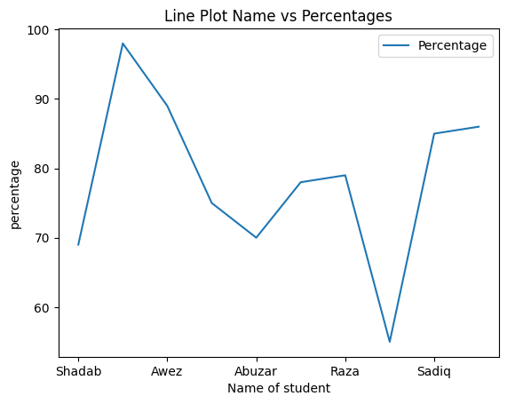

Q8
Program:

#importing Library
import pandas as pd
import matplotlib.pyplot as plt
#Creating Da Frame
df=pd.DataFrame(columns=['Name','Age','Percentage']);
df.loc[0]=('Shadab',20,69)
df.loc[1]=('Aman',22,98)
df.loc[2]=('Awez',20,89)
df.loc[3]=('Ghar',20,75)
df.loc[4]=('Abuzar',20,70)
df.loc[5]=('Mudasir',24,78)
df.loc[6]=('Raza',23,79)
df.loc[7]=('Sibtain',25,55)
df.loc[8]=('Sadiq',21,85)
df.loc[9]=('Ayman',26,86)
#view Dataframe
print(df)
#ploting line plot
plt.scatter(x=df['Name'],y=df['Percentage'])
plt.title('Line Plot Name vs Percentages')
plt.xlabel('Name of student')
plt.ylabel('percentage')
plt.show()

Output:
Name Age Percentage
0 Shadab 20 69
1 Aman 22 98
2 Awez 20 89
3 Ghar 20 75
4 Abuzar 20 70
5 Mudasir 24 78
6 Raza 23 79
7 Sibtain 25 55
8 Sadiq 21 85
9 Ayman 26 86
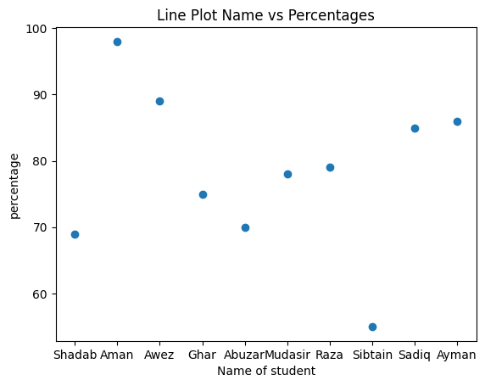

Set B
Q1:
Program:
#import libraries
import pandas as pd
#Reading csv file
data=pd.read_csv('HeightWeight.csv')

#creating data frame
df=pd.DataFrame(data)

#Displaying first,last 10 and random 20 rows
print("First 10 rows:",df.head(10))
print("Last 10 rows:",df.tail(10))
print("Random 20 rows:",df.sample(20))

Output:
First 10 rows: Index Height(Inches) Weight(Pounds)
0 1 65.78331 112.9925
1 2 71.51521 136.4873
2 3 69.39874 153.0269
3 4 68.21660 142.3354
4 5 67.78781 144.2971
5 6 68.69784 123.3024
6 7 69.80204 141.4947
7 8 70.01472 136.4623
8 9 67.90265 112.3723
9 10 66.78236 120.6672
Last 10 rows: Index Height(Inches) Weight(Pounds)
24990 24991 69.97767 125.3672
24991 24992 71.91656 128.2840
24992 24993 70.96218 146.1936
24993 24994 66.19462 118.7974
24994 24995 67.21126 127.6603
24995 24996 69.50215 118.0312
24996 24997 64.54826 120.1932
24997 24998 64.69855 118.2655
24998 24999 67.52918 132.2682
24999 25000 68.87761 124.8742
Random 20 rows: Index Height(Inches) Weight(Pounds)
20400 20401 67.71530 127.9327
13205 13206 64.74880 136.3069
24317 24318 68.93279 117.7980
4739 4740 66.23692 122.5351
9284 9285 67.53657 100.1540
8513 8514 69.85744 132.3308
1029 1030 68.35638 123.5943
22392 22393 70.06192 124.4469
13099 13100 67.34605 118.8282
13999 14000 66.35824 122.6852
8511 8512 65.93684 130.2864
22719 22720 67.34877 126.6511
15975 15976 67.55854 132.8552
3168 3169 65.25826 110.8818
13746 13747 66.23251 127.9094
16100 16101 65.90327 121.5589
19165 19166 69.89842 143.7624
16145 16146 74.47517 130.9092
14315 14316 67.73894 135.2910
11214 11215 63.33119 112.6251

Q2:
Program:
#import libraries
import pandas as pd
#Reading csv file
data=pd.read_csv('HeightWeight.csv')

#creating data frame
df=pd.DataFrame(data)

#Displaying shape,size and tpes
print("shape of DataFrame:",df.shape)
print("size of DataFrame:",df.size)
print("datatype of Dataframe:",df.dtypes)

Output:
shape of DataFrame: (25000, 3)
size of DataFrame: 75000
datatype of Dataframe: Index int64
Height(Inches) float64
Weight(Pounds) float64

Q3
Program:
#import libraries
import pandas as pd
#Reading csv file
data=pd.read_csv('HeightWeight.csv')

#creating data frame
df=pd.DataFrame(data)

#Displaying shape,size and tpes
print("Description of DataFrame:",df.describe())
Output:
Description of DataFrame: Index Height(Inches) Weight(Pounds)
count 25000.000000 25000.000000 25000.000000
mean 12500.500000 67.993114 127.079421
std 7217.022701 1.901679 11.660898
min 1.000000 60.278360 78.014760
25% 6250.750000 66.704397 119.308675
50% 12500.500000 67.995700 127.157750
75% 18750.250000 69.272958 134.892850
max 25000.000000 75.152800 170.924000

Q4
Program:
import pandas as pd
import numpy as np
data=pd.read_csv('HeightWeight.csv')
df=pd.DataFrame(data)

#Displaying no of observation,missing values and noan values
print("Number of Observation:",df['Index'].size)
m=df.isnull()
print("Missing Values:",m.size)
y=np.isnan(df)
print("nan Values:",y.size)

Output:
Number of Observation: 25000
Missing Values: 75000
nan Values: 75000
Q5:
Program:
import pandas as pd
import numpy as np
data=pd.read_csv('HeightWeight.csv')
df=pd.DataFrame(data)
df['BMI']=((df['Weight(Pounds)']/df['Height(Inches)'])**2)
print("*****After adding column:*****:",df)

Output:
*****After adding column:*****: Index Height(Inches) Weight(Pounds) BMI
0 1 65.78331 112.9925 2.950311
1 2 71.51521 136.4873 3.642400
2 3 69.39874 153.0269 4.862195
3 4 68.21660 142.3354 4.353572
4 5 67.78781 144.2971 4.531187
... ... ... ... ...
24995 24996 69.50215 118.0312 2.884013
24996 24997 64.54826 120.1932 3.467294
24997 24998 64.69855 118.2655 3.341389
24998 24999 67.52918 132.2682 3.836436
24999 25000 68.87761 124.8742 3.286921

[25000 rows x 4 columns]
Q6
Program:
import pandas as pd
import numpy as np
data=pd.read_csv('HeightWeight.csv')
df=pd.DataFrame(data)
df['BMI']=((df['Weight(Pounds)']/df['Height(Inches)'])**2)
print(" Maximum of BMI=",max(df['BMI']))
print("Minimum of BMI=",min(df['BMI']))
Ouput:
Maximum of BMI= 5.933879009339526
Minimum of BMI= 1.531593289721334
Q7:
Program:
import pandas as pd
import matplotlib.pyplot as plt
data=pd.read_csv('HeightWeight.csv')
df=pd.DataFrame(data)
df['BMI']=((df['Weight(Pounds)']/df['Height(Inches)'])**2)
plt.scatter(x=df['Height(Inches)'],y=df['Weight(Pounds)'],c='lightblue')
plt.title("Scatter PLot")
plt.xlabel("Height(Inches)")
plt.ylabel("Weight(Pounds)")
plt.show()
Output:
